Group 10
Simulation based analysis of Spanning Trees and its relation with Balance factor
(June 2016)

Gaurav Palande^{#1}, Gagandeep Bansal^{#2}

#Department of Computer Science, California State University, Long Beach, CA 90840, USA
¹Gaurav.Palande@student.csulb.edu
²Gagandeep.Bansal@student.csulb.edu

Abstract—The paper illustrates the need and advantages of implementing spanning tree across a network topology. There is an attempt towards simulating the various graph topologies (hypercube and star) across a relevant visual simulator (Cisco Packet Tracer) to help us analyze the importance of spanning trees, in particular the Asymptotically Balanced Spanning Tree (ABST) and the Greedy Spanning Tree (GST), in areas of broadcasting and communications

Index Terms—Spanning tree, Network Broadcast Storm, Balanced spanning tree, Broadcast storm, Cisco Packet Tracer, Asymptotically Balanced Spanning Tree, Greedy Spanning Tree.

Introduction
This paper illustrates the simulation of packet routing mechanism implemented through spanning trees and balanced spanning trees. There is an emphasis on how the message is passed to every node in the tree and what are the advantages of using spanning trees. The two types of spanning trees, such as Asymptotically Balanced Spanning Tree and Greedy spanning tree have been discussed [8].
Using the spanning tree in network graph topology has a significant improvement on its broadcasting and networking ability. Star graph’s superiority over the hypercube has been demonstrated in [1], [2] [3] and [8]. Broadcasting issues such as broadcast storm can occur when routing mechanisms are absent.
Through simulation in Cisco packet tracer, the relevant topologies have been assessed. The mechanism for routing has been analyzed and implemented to create the topologies. An attempt has been made to create the Balanced spanning trees for the topologies.
Assessment of the network has been conducted using ICMP packet transfer rates across individual nodes.

Network broadcast storm
The overwhelming prevalence of broadcast and multicast traffic across a network system generates a broadcast storm or a network storm. Messages sent or broadcasted across the network by a node are in turn rebroadcasted back to the same node by other nodes along the same link. These messages in turn are rebroadcasted back and forth, leading to a system wide melt down and an unresponsive network.
The main reasons for broadcast storm occurrence is poor network routing configuration. Although intelligent network devices and configurations help prevent their occurrences, they contribute towards the major issues encountered in computer network systems today.

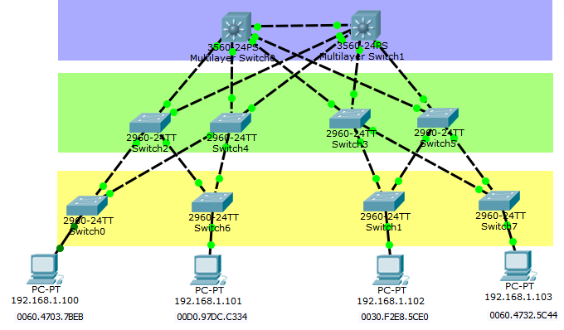
Fig. 1: Broadcast Storm

For example, suppose there is a small LAN network constituting of ten switches (Switch 0 through Switch 7) and 2 multilayer switches (Multilayer switch 0 and Multilayer switch 1) and three network segments (Green, yellow and white). Four nodes are connected within this network as shown in Fig. 1. Now, if the first node wants to transfer a data packet to the last node, then the packet is broadcasted from Switch 0 over to the green segment. Switch 2 and Switch 4 forward and broadcast the message to the other segments. This continues in the other segments as well. Thus, a flood loop or a broadcast loop is generated as a result of these exchanges, causing a system wide meltdown and failure of all network links.
The key factors for a broadcast storm are inappropriate network management schemes, improper network monitoring and lack of proper network routing configuration.
Network routing configurations help in efficient management and routing of network traffic. With the help of spanning tree and application software, network topologies can be constructed and analyzed.

Spanning trees
The tree structure is considered as a versatile architecture suitable for a number of parallel processing applications [6], [7], [8]. Spanning trees provide a comprehensive tool in solving communication problems such as broadcasting storm. A 4 – cube spanning binomial trees as in Fig. 2, can simplify and limit the broadcasting of messages to relevant links across the network.

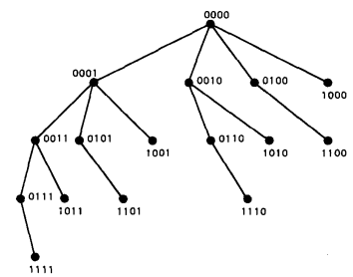
Fig. 2: 4-cube Spanning Binomial tree

An Optimal balanced SBnT as defined by Johnson and Ho. Tries to allocate (total number of nodes)/n nodes at the next level and so forth to evenly distribute the tree across the graph. The former is shown in Fig. 2[5], [8].

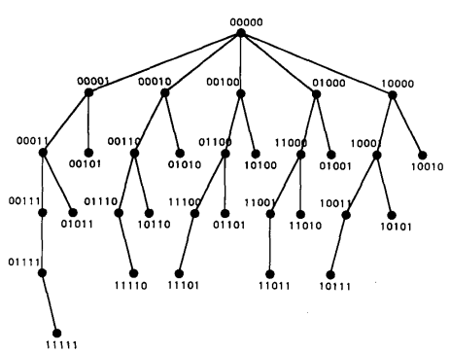
Fig. 3: 5-cube Balanced Spanning Binomial tree

Importance of balance factor
Balance factor is defined as the ratio of the sizes of the largest subtree of the root to that of the smallest subtree of the same root. For a tree T, balance factor, that measures the efficiency in reachability and broadcastability of the root node across the tree, is denoted by BF(T). It is desired that BF(T) be close to 1 [4], [8]. The balance factor of a spanning tree can be calculated as
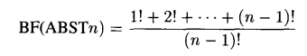………… (1)

Fig. 4 graph illustrates that as the value of n increases, the value of balance factor reaches closer to the optimal value of 1, with worse cases at 3 and 4 with value 1.5.

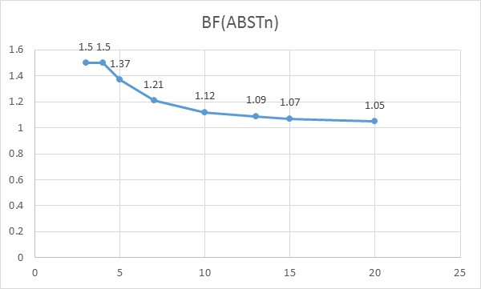
Fig. 4: Balance factor with increasing number of nodes

Greedy Spanning tree for n – star
The Greedy Spanning tree (GST) attempts to achieve minimum root to node distance while achieving optimal balance.
The tree is also known as the smallest misplaced first spanning tree. Each child node is made by switching the first symbol with the other symbols in an ascending order. The next switching occurs at the next level and the remaining permutations are implemented until either the last symbol is switched or the total number of nodes are achieved and arranged [4], [8]. The 4-star spanning tree is illustrated in Fig. 5.
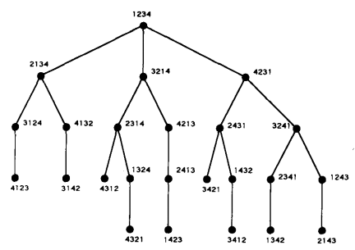
Fig. 5: 4-star Greedy Spanning Tree

Simulation
Further along, we look into the mechanism that helps the hypercube topology to broadcast messages optimally.
The mechanism works by every node storing relevant information of its neighbors. This information is referred to during message transmission and construct an optimal path for reaching the desired destination.
By sending copies across individual subtrees, the spanning tree also exhibits fault tolerance. In case of the link failure, another dynamic spanning tree can be constructed with root as the parent node of the faulty node and the copies of data can be transferred along the network to its destination.
So for our final project we combined the ideas of our individual papers into a work where we can perform our calculations and check for the results. We decided to do simulation on various topologies and orientations of trees. The results are captured and the efficiency of current STA mechanism of Cisco Packet Tracer and basic idea of balanced binomial tree across the topology are realized.

Tool
Packet tracer is a visual simulation program designed by Cisco Systems which allows users to create various topologies of network and other computer networks. The software allows users to simulate the configuration of Cisco routers and switches using a simulated command line interface. Packet Tracer makes utilization of a move and customize client interface, permitting clients to include and expel simulated system gadgets as they see fit.

Topology realization
Designed network topology is shown in the following figures. All routers are connected to each other and corresponding end nodes by distinct IP addresses. The links connecting the routers have also been assigned unique IP address for distinction among each other and routing purposes.

3-cube

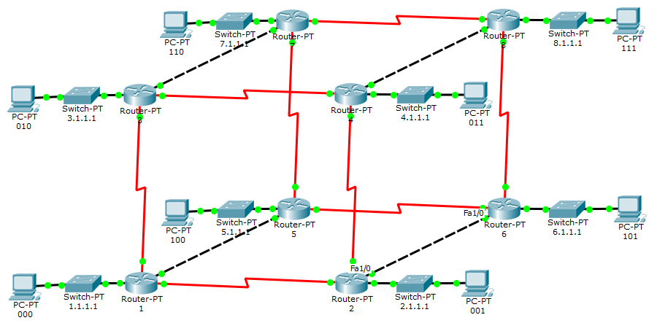
Fig. 6: 8 PC-PT end nodes, 8 Switch-PT switches to connect the end nodes with the router and 8 Router-PT routers arranged in the 3 cube topology.

3-star

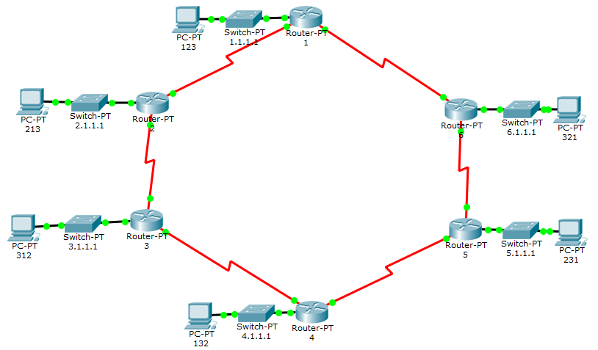
Fig. 7: 6 PC-PT end nodes, 6 Switch-PT switches to connect the end nodes with the router and 6 Router-PT routers arranged in the 3-star topology.

4-cube

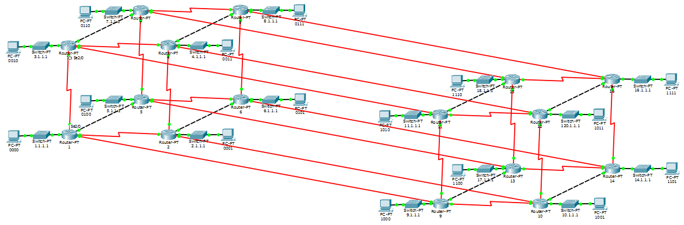
Fig. 8: 16 PC-PT end nodes, 16 Switch-PT switches to connect the end nodes with the router and 16 Router-PT routers arranged in the 4-cube topology.

4-star

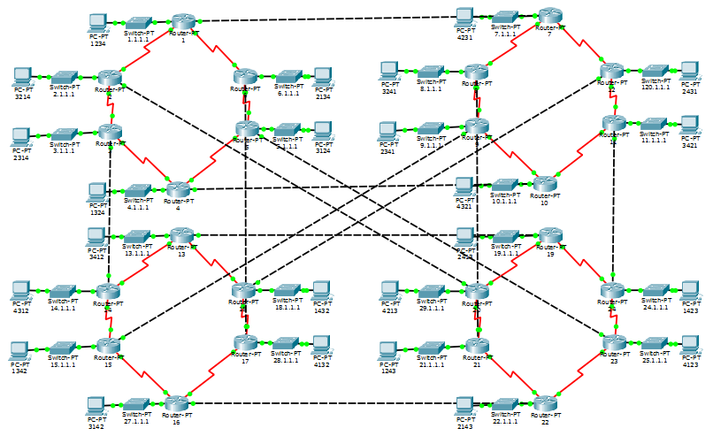
Fig. 9: 24 PC-PT end nodes, 24 Switch-PT switches to connect the end nodes with the router and 24 Router-PT routers arranged in the 4-star topology.

Routing mechanism in Cisco Packet tracer
RIP is a distance vector routing protocol. Through information broadcasting at specific time intervals, usually every 30 seconds, provides data to its neighbors.
In the scenario where a destination has multiple nodes in between, the router uses metrics to select the correct path till the destination. RIP uses hop count and Routing by Rumor to find the desired path to reach the destination.
The protocol gets an idea about the route from directly connected neighbors which in turn have learned it through their directly connected neighbors. Thus, through this assumption, routing information is gathered and made accessible at the source node.
The Protocol periodically broadcasts the network routing information across the network to get all the nodes updated with the current routing information. The broadcast is sent using destination IP as 255.255.255.255. The mechanism does not care if the nodes listen or miss the updates since they can access this information through their neighbors at a later information exchange time.
Hop count gives the router the number of hops on the rout to the destination i.e. the number of nodes encountered from that router to the destination node.

Balanced spanning tree realization
We first create the corresponding balanced spanning tree for the presented topology. This is done by either disabling the links that are not required. In this case, we have deleted the links that need to be disabled. Using RIP protocol and CDP (Cisco Discovery protocol), the individual routers RIP cache are fed with the corresponding end node IP address as well as the individual IP address of connected links. The RIP protocol uses the Routing by Rumor method to gather the information of all the nodes connected to the corresponding link. The protocol also gathers information of nodes that lie beyond the connected node.

3-cube balanced spanning tree

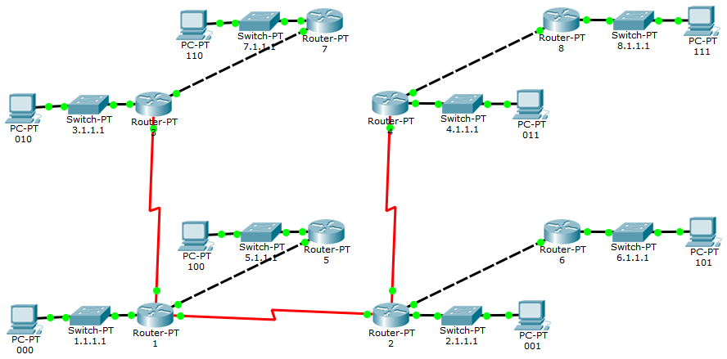
Fig. 10: 8 PC-PT end nodes, 8 Switch-PT switches to connect the end nodes with the router and 8 Router-PT routers arranged in the 3-cube balanced spanning tree topology.

3-star greedy spanning tree

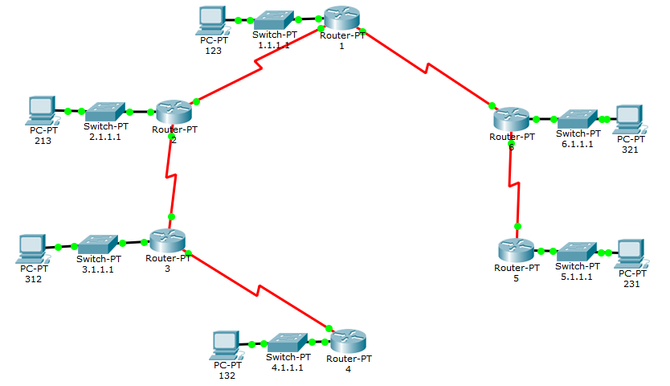
Fig. 11: 6 PC-PT end nodes, 6 Switch-PT switches to connect the end nodes with the router and 6 Router-PT routers arranged in the 3-star greedy spanning tree topology.

4-cube balanced spanning tree

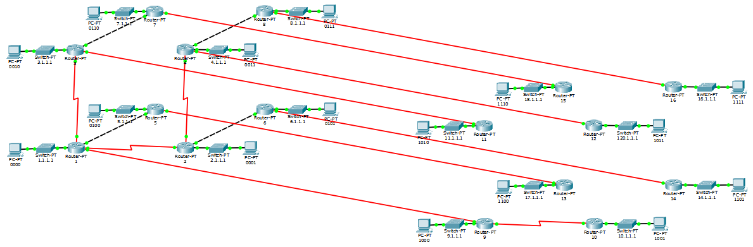
Fig. 12: 16 PC-PT end nodes, 16 Switch-PT switches to connect the end nodes with the router and 16 Router-PT routers arranged in the 4-cube balanced spanning tree topology.

4-star greedy spanning tree

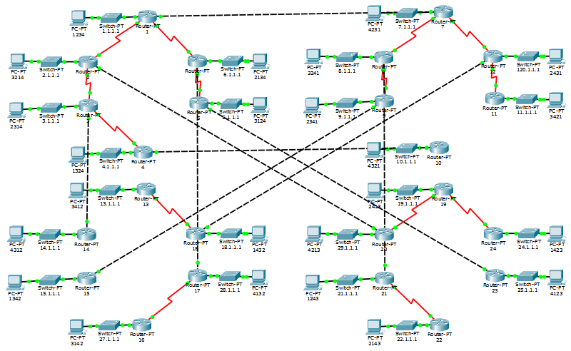
Fig. 13: 24 PC-PT end nodes, 24 Switch-PT switches to connect the end nodes with the router and 24 Router-PT routers arranged in the 4-star balanced spanning tree topology.

Result of comparison
The individual nodes are evaluated by sending an ICMP (Internet Control Message Protocol) packet from the root node of the corresponding balanced and greedy spanning tree. For convenience purposes, we have assigned the root node as 0th node and the spanning tree is constructed through this root node. The ICMP packet is sent to the destination node and the to and fro journey time is calculated.
Five readings have been collected for each node and the mean of these values is calculated. This ensures that the response time taken into consideration is not affected through deviation. The values were then plotted along the Y-Axis at a scale of milliseconds and the individual ports of the tree against the X-Axis.

3-cube

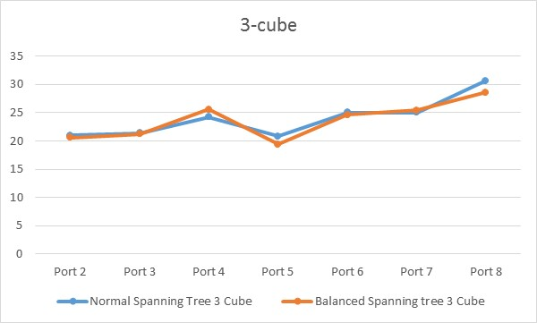
Fig. 14: Comparison of ICMP response time of STA enabled 3-cube topology with its RIP enabled Balanced Spanning tree topology counterpart

3-star

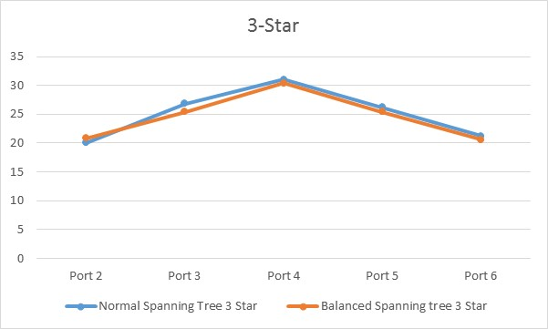
Fig. 15: Comparison of ICMP response time of STA enabled 3-star topology with its RIP enabled Greedy Spanning tree topology counterpart

4-cube

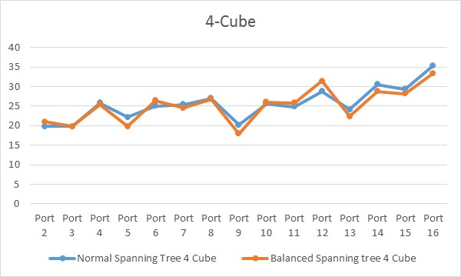
Fig. 16: Comparison of ICMP response time of STA enabled 4-cube topology with its RIP enabled Balanced Spanning tree topology counterpart

4-star

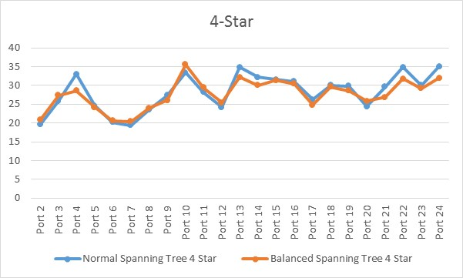
Fig. 17: Comparison of ICMP response time of STA enabled 4-star topology with its RIP enabled Greedy Spanning tree topology counterpart

Conclusion
The simulation through disabling links and creating balanced spanning tree along with the use of RIP protocol, is feasible and enables us to demonstrate efficient response time. The simulation also showcased the physical aspect of the theory which is network topology and spanning trees.

References
[1] S. B. Akers, D. Horel and B. Krisnamurthy, “The Star graph: An attractive alternative to the n-cube,” in International Conference Parallel Processing, pp. 393-400, 1987
[2] S. B. Akers and B. Krisnamurthy, “A group-theoretic model for symmetric interconnection networks,” in International Conference Parallel Processing, 1986, pp. 216-223
[3] A. Menn and A. K. Somani, “An efficient sorting algorithm for the star graph interconnection network,” International Conference Parallel Processing, vol.3, 1990, pp. 1-8
[4] Khaled Day and Anand Tripathi, “A Comparative Study of Topological Properties of Hypercubes and Star Graphs,” IEEE Transactions on Parallel and Distributed systems, vol. 5, no. 1, January 1994, pp. 35-37
[5] S. L. Johnson and C. T. Ho, “Optimum broadcasting and personalized communication in hypercubes,” IEEE Trans. Computing, vol. 38, no. 9, pp. 1249-1268, Sept. 1989.
[6] S. Browning, “The tree machine: A highly concurrent computing environment,” Ph.D. dissertation, Department of Computer Science, California Institute of Technology, 1980
[7] N. B. Nripendra and S. Srinivas, “A reconfigurable tree architecture with multistage interconnection network,” IEEE Trans. Computing, vol. 39, no. 12, pp. 1481-1485, Dec. 1990.
[8] Gaurav Palande, “Analysis of Spanning Trees for Star Graphs”, Self-study paper, CECS 546 Fault Tolerant Systems, Department of Computer Science, California State University, Long Beach, Jun 2016

